Champions Cup takker af for i år med et fantastisk Showshine-show.
Tusind tak til alle deltagere, hjælpere, sponsorer og tilskuere.

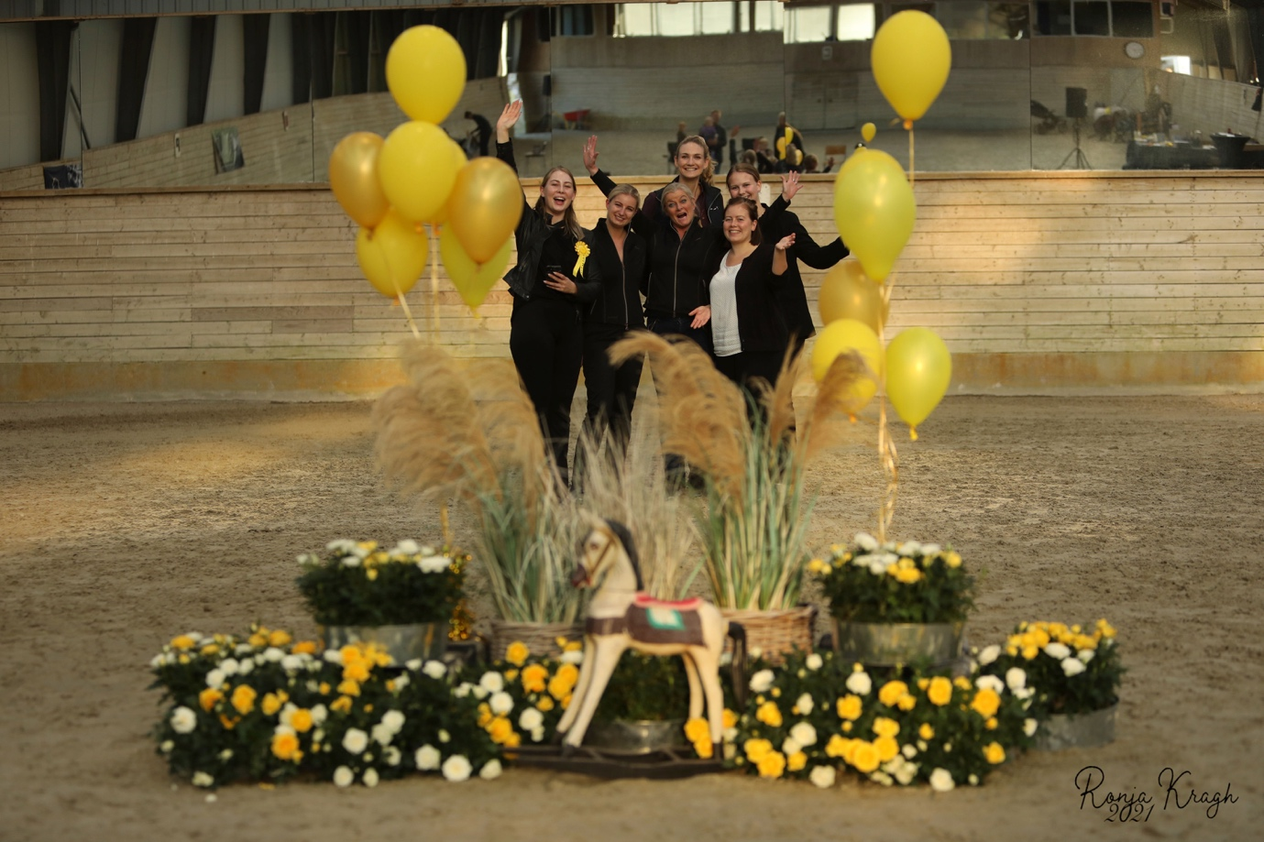

Jill Poulsen – JP Miniatures
Gitte & Katja Bager – Highlight Miniatures

1) Experienced mares

1st | 2nd | 3rd
Kingwood After Dark Cose Della Vita | Nicole Kidman is a Superstar | SWG Breaking The Storm in High Heels

2) Experienced stallions

1st | 2nd | 3rd
EBF Mi Armani | James Dean is a Superstar | FL Creek Rebels Newt Scamander

3) Experienced geldings

1st | 2nd | 3rd

4) Novice mares

1st | 2nd | 3rd
Marielunds Ballistics Vanilla Kiss | Godts Wild Bluebell | Highlight Miss Allure by Night

5) Novice stallions

1st | 2nd | 3rd
Steals Painted Laroo | Vesterøs Amazing Vivaldi | FL Creek Rebels Newt Scamander

6) Novice geldings

1st | 2nd | 3rd
LM Wild Painted Lazett | Red Clouds Curious Curtis | SP Domingos King of Hearts

7) Versatility 34” and under

1st | 2nd | 3rd
The Golden Baron of Bali Hai

8) Versatility over 34”

1st | 2nd | 3rd

9) Hunter 34” and under

1st | 2nd | 3rd
The Golden Baron of Bali Hai

10) Hunter over 34”

1st | 2nd | 3rd
Ketty | Godts Wild Bluebell

11) Jumper 34” and under

1st | 2nd | 3rd
Eliminated

12) Jumper over 34”

1st | 2nd | 3rd

13) Weanling and yearling mares 30” and under

1st | 2nd | 3rd
D&T Bey Dancing Ballerina

14) Weanling and yearling mares 30” – 32”

1st | 2nd | 3rd
HHM Precious Jade | Teglmosens Flawless Gully Star

15) Weanling and yearling mares over 32”

1st | 2nd | 3rd
Highlight Miss Allure by Night

16) Roadster 34” and under

1st | 2nd | 3rd
The Golden Baron of Bali Hai

17) Roadster over 34”

1st | 2nd | 3rd
26

18) Grand Champion roadster

Grand Champion | Reserve Grand Champion
The Golden Baron of Bali Hai

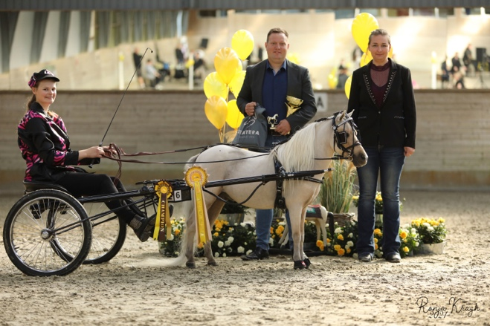

19) Weanling and yearling stallions 30” and under

1st | 2nd | 3rd

20) Weanling and yearling stallions 30” – 32”

1st | 2nd | 3rd
EBF Mi Unique | Hyrule Horses Nobu | A&J Risin Saa’iq

21) Weanling and yearling stallions over 32”

1st | 2nd | 3rd

22) Costume adults

1st | 2nd | 3rd
Red Clouds Curious Curtis | SP Domingos King of Hearts

23) Color, halter, obstacle

1st | 2nd | 3rd
Steals Painted Laroo | Ketty | Paradise Ranch Montys Island Girl

24) 2 year old mares 31” and under

1st | 2nd | 3rd

25) 2 year old mares 31” – 33”

1st | 2nd | 3rd

26) 2 year old mares over 33”

1st | 2nd | 3rd

27) Grand Champion junior mares

Grand Champion | Reserve Grand Champion
HMM Precious Jade | D&T Bey Dancing Ballerina

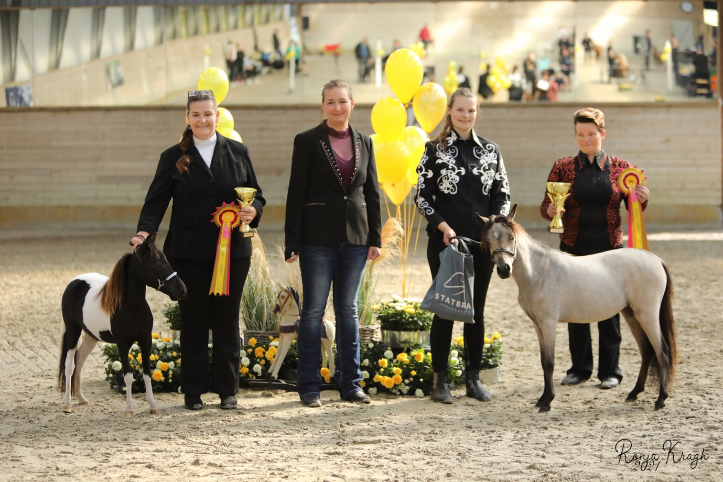

28) Single pleasure driving 34” and under

1st | 2nd | 3rd
Abrias Daring Eclipse

29) Single pleasure driving over 34”

1st | 2nd | 3rd

30) Grand Champion single pleasure driving

Grand Champion | Reserve Grand Champion
Abrias Daring Eclipse

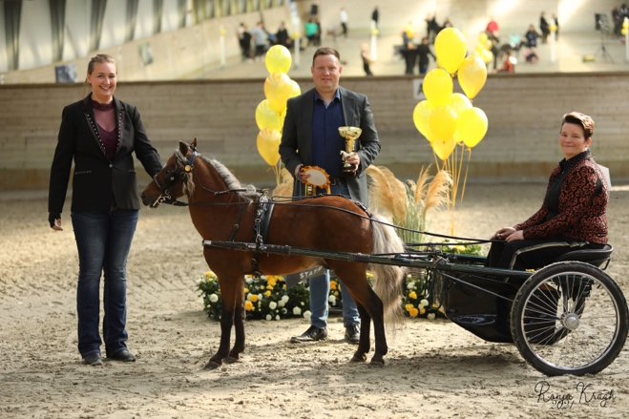

31) 2 year old stallions 31” and under

1st | 2nd | 3rd

32) 2 year old stallions 31” – 33”

1st | 2nd | 3rd
EBF Mi Armani | FL Creek Rebels Newt Scamander | EBF SH Di Versace

33) 2 year old stallions over 33”

1st | 2nd | 3rd

34) Grand Champion junior stallions

Grand Champion | Reserve Grand Champion
EBF Mi Armani | EBF Mi Unique

35) Solid color

1st | 2nd | 3rd
EBF Mi Armani | Søsteds Black Shooting Star

36) Multi color

1st | 2nd | 3rd
D&T Bey Dancing Ballerina | Godts Wild Bluebell | EBF Mi Unique

37) Presidents Touch of Class

1st | 2nd | 3rd
Steals Painted Laroo | The Golden Baron of Bali Hai

38) Reinsmanship

1st | 2nd | 3rd
The Golden Baron of Bali Hai

LUNCH 30 minutes

39) YOUTH costume

1st | 2nd | 3rd | 4th | 5th | 6th
4  Febe | 19  Rose

40) YOUTH exhibiting a mare

1st | 2nd | 3rd | 4th | 5th | 6th
16  Celina | 18  Nanna | 13  Malou | 21  Sophia

41) YOUTH exhibiting a gelding

1st | 2nd | 3rd | 4th | 5th | 6th
12  Alma | 4  Febe | 19  Rose

42) YOUTH exhibiting a stallion (exhibitor must be 13-18 years of years)

1st | 2nd | 3rd | 4th | 5th | 6th

43) YOUTH liberty

1st | 2nd | 3rd | 4th | 5th | 6th
18  Nanna | 12  Alma | 13  Malou | 4  Febe | 16  Celina

44) YOUTH driving

1st | 2nd | 3rd | 4th | 5th | 6th

45) YOUTH performance

1st | 2nd | 3rd | 4th | 5th | 6th
16  Celina | 13  Malou | 4  Febe | 19  Rose | 12  Alma

The judge will choose the handler and horse that has done most impression on him during the YOUTH division. He will choose his favorite YOUTH.
46) Best YOUTH in show

1st
Febe Thomsen

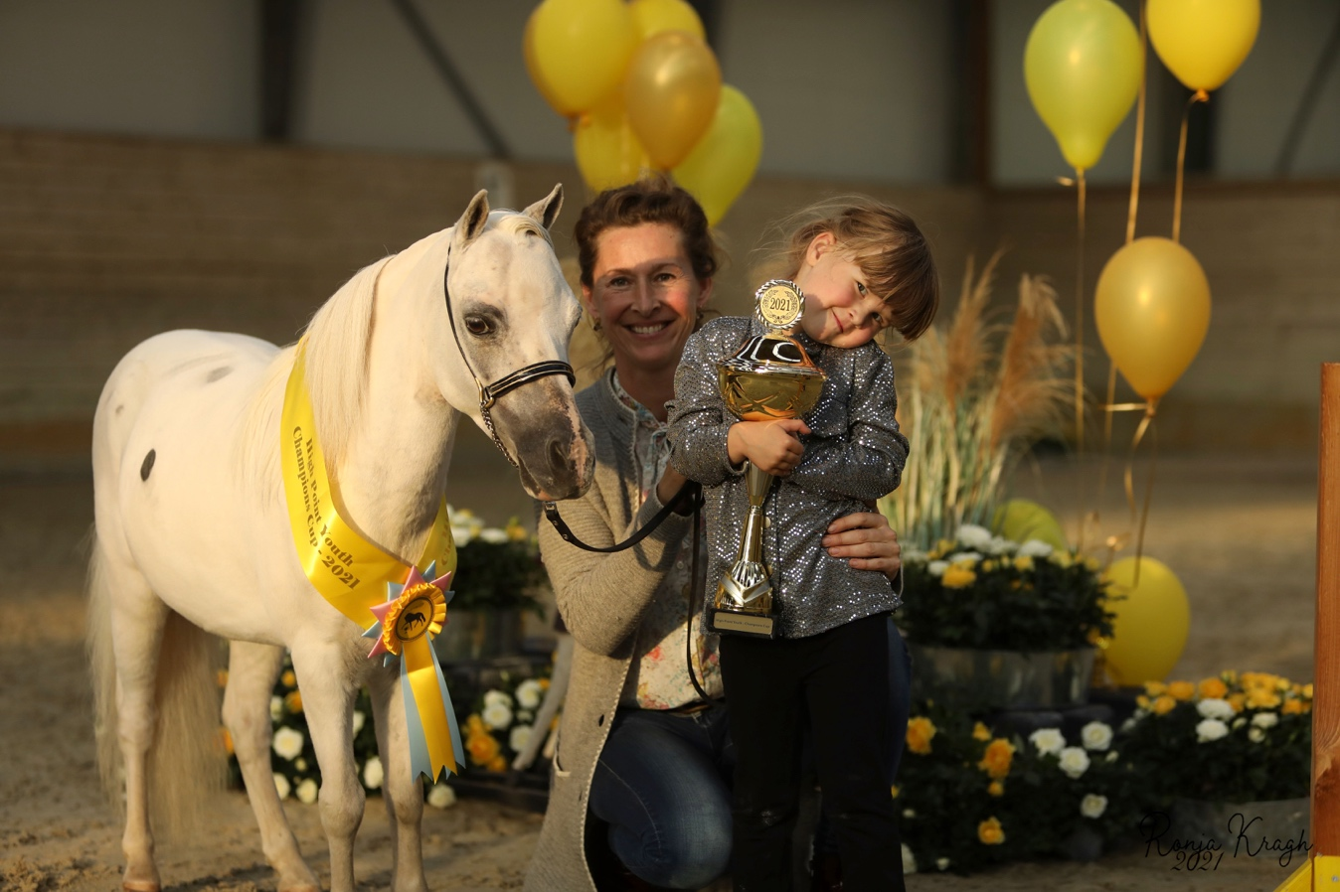

47) Halter obstacle

1st | 2nd | 3rd
The Golden Baron of Bali Hai | SWG Breaking the Storm in High Heels | Nicole Kidman is a Superstar

48) Driving obstacle

1st | 2nd | 3rd
The Golden Baron of Bali Hai | Steals Painted Laroo

49) Country pleasure driving 34” and under

1st | 2nd | 3rd
The Golden Baron of Bali Hai

50) Country pleasure driving over 34”

1st | 2nd | 3rd
Ketty

51) Grand Champion country pleasure driving

Grand Champion | Reserve Grand Champion
The Golden Baron of Bali Hai  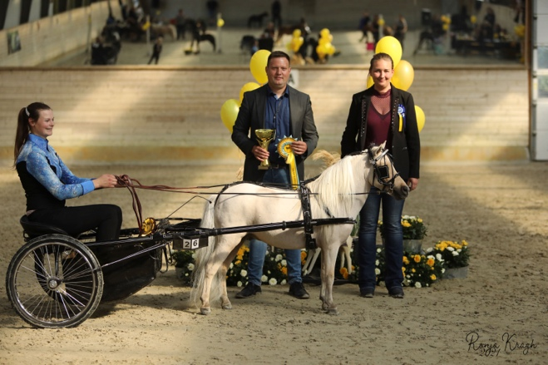 | Ketty  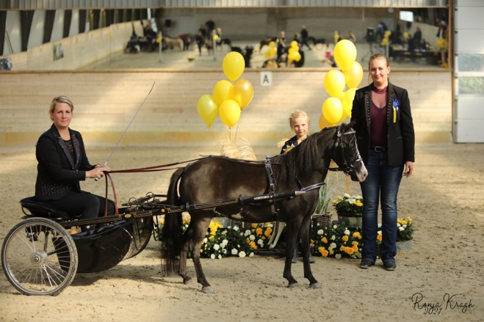

52) Junior geldings 34” and under

1st | 2nd | 3rd

53) Junior geldings over 34”

1st | 2nd | 3rd

54) Senior geldings 34” and under

1st | 2nd | 3rd
Red Clouds Curious Curtis | LM Wild Painted Lazett

55) Senior geldings over 34”

1st | 2nd | 3rd
PS Steal The Moment

56) Grand Champion geldings

Grand Champion | Reserve Grand Champion
PS Steal The Moment | Red Clouds Curious Curtis

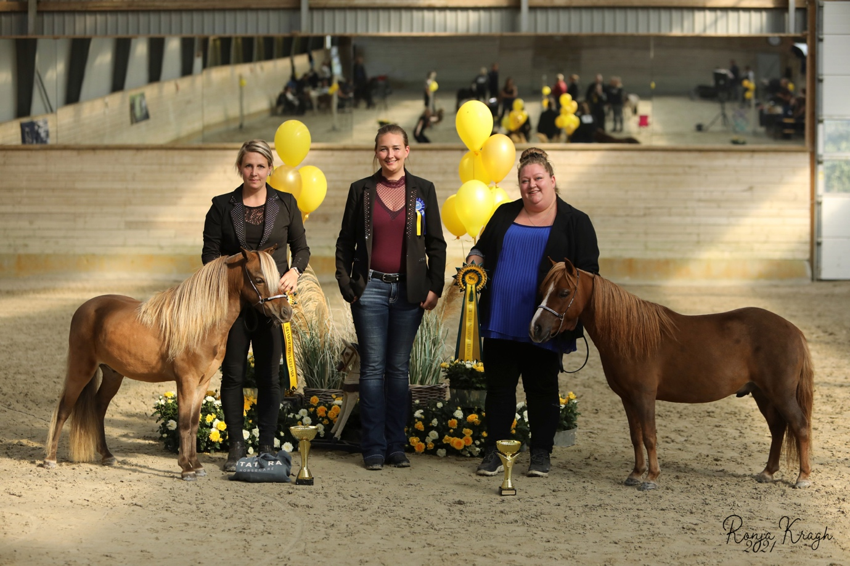

57) Senior mares 30” and under

1st | 2nd | 3rd
Kingswood After Dark Cose Della Vita

58) Senior mares 30” – 34”

1st | 2nd | 3rd
Nicole Kidman is a Superstar

59) Senior mares 32” – 34”

1st | 2nd | 3rd
Marielunds Ballistic Treasure | SWG Breaking The Storm in High Heels | Paradiseranch Montys Island Girl

60) Senior mares over 34”

1st | 2nd | 3rd
Ketty

61) Grand Champion senior mares

Grand Champion | Reserve Grand Champion
Kingswood After Dark Cose Della vita | Marielunds Ballistic Treasure

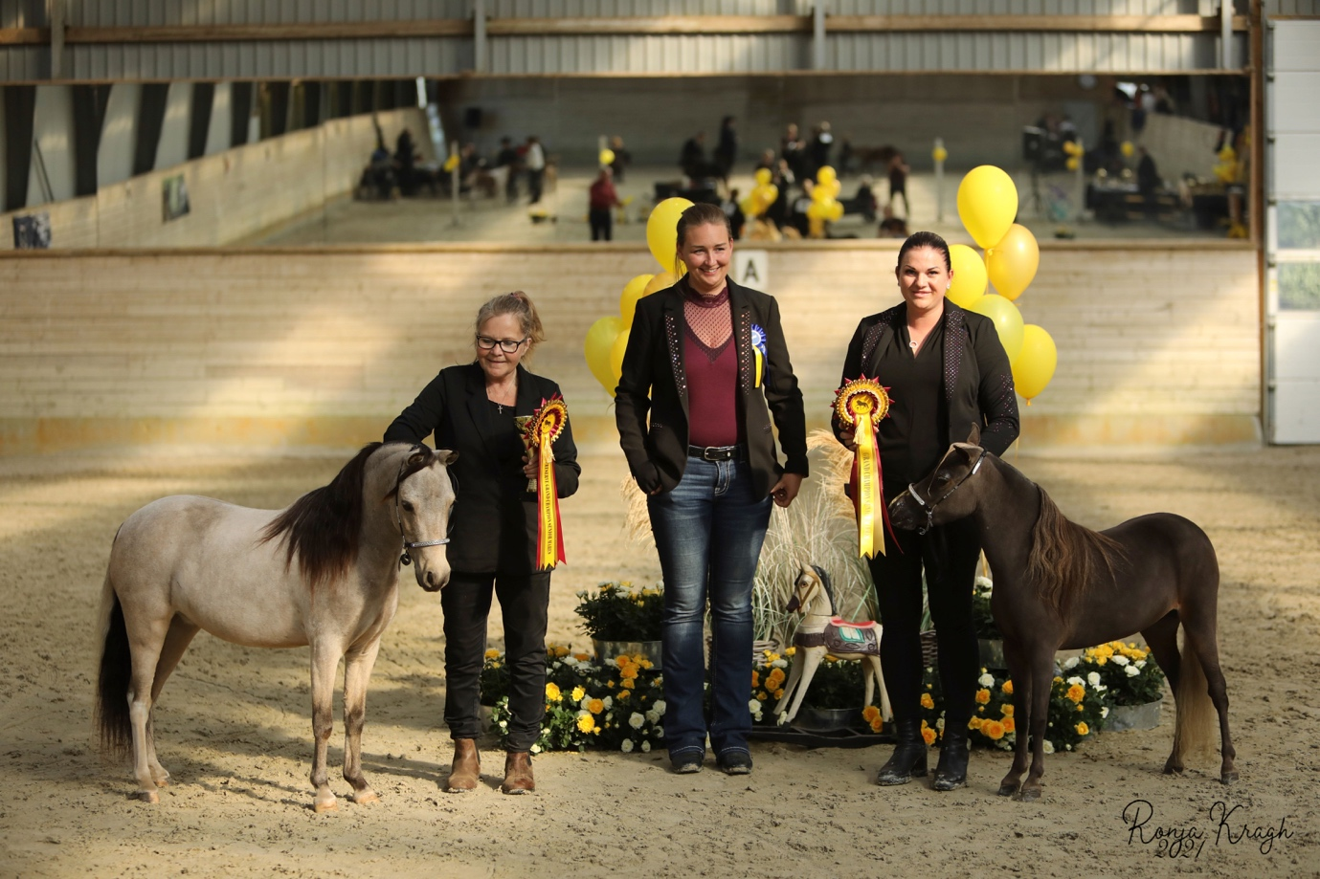

62) Showmanship

1st | 2nd | 3rd
Nicole Kidman is a Superstar | Paradiseranch Montys Island Girl

63) Liberty 34” and under

1st | 2nd | 3rd
SWG Breaking The Storm in High Heels | Marielunds Ballistic Vanilla Kiss | D&T Bey Dancing Ballerina

64) Liberty over 34”

1st | 2nd | 3rd
Highlight Mr. Valentino by Night | PS Steal The Moment | Ketty

65) Senior stallions 30” and under

1st | 2nd | 3rd

66) Senior stallions 30” – 32”

1st | 2nd | 3rd

67) Senior stallions 32” – 34”

1st | 2nd | 3rd
Steals Painted Laroo | Marielunds Ballistic Solid Black | Barry White is a Superstar

68) Senior stallions over 34”

1st | 2nd | 3rd
James Dean is a Superstar | Søsteds Black Shooting Star | Highlight Mr. Valentino by Night

69) Grand Champion senior stallions

Grand Champion | Reserve Grand Champion
James Dean is a Superstar | Steals Painted Laroo

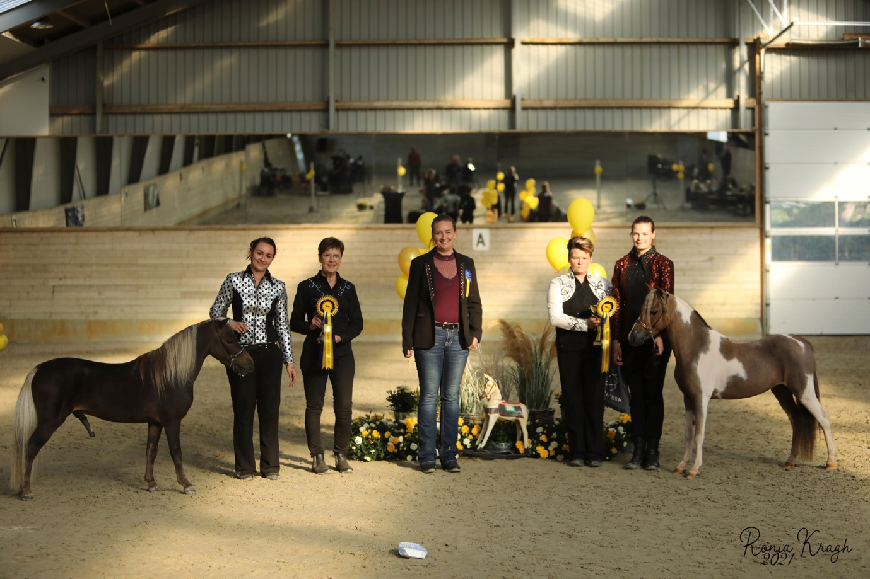

70) Classic pleasure driving 34” and under

1st | 2nd | 3rd
Steals Painted Laroo | Marielunds Ballistic Treasure | Marielunds Ballistic Solid Black

71) Classic pleasure over 34”

1st | 2nd | 3rd
PS Steal The Moment

72) Grand Champion classic pleasure driving

Grand Champion | Reserve Grand Champion
PS Steal The Moment  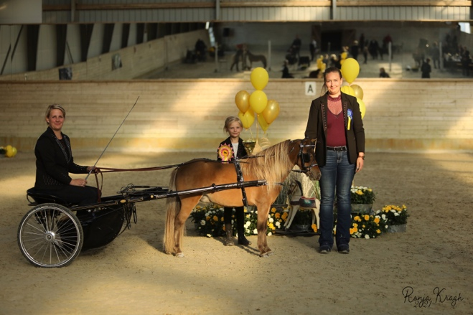 | Steals Painted Laroo  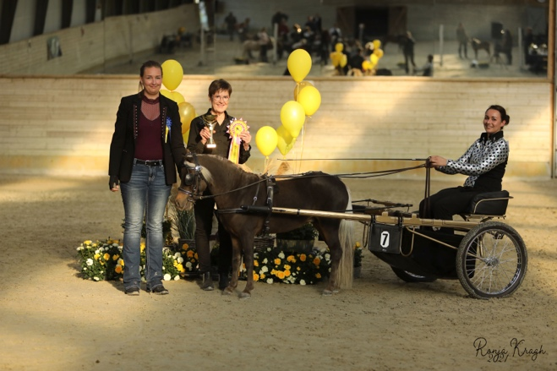

The judge will choose the horses that has done most impression on him during the show.
He will choose his favorite in the following categories:

73) Best Halter Horse in Show (Supreme Champion)

1st
EBF Mi Armani

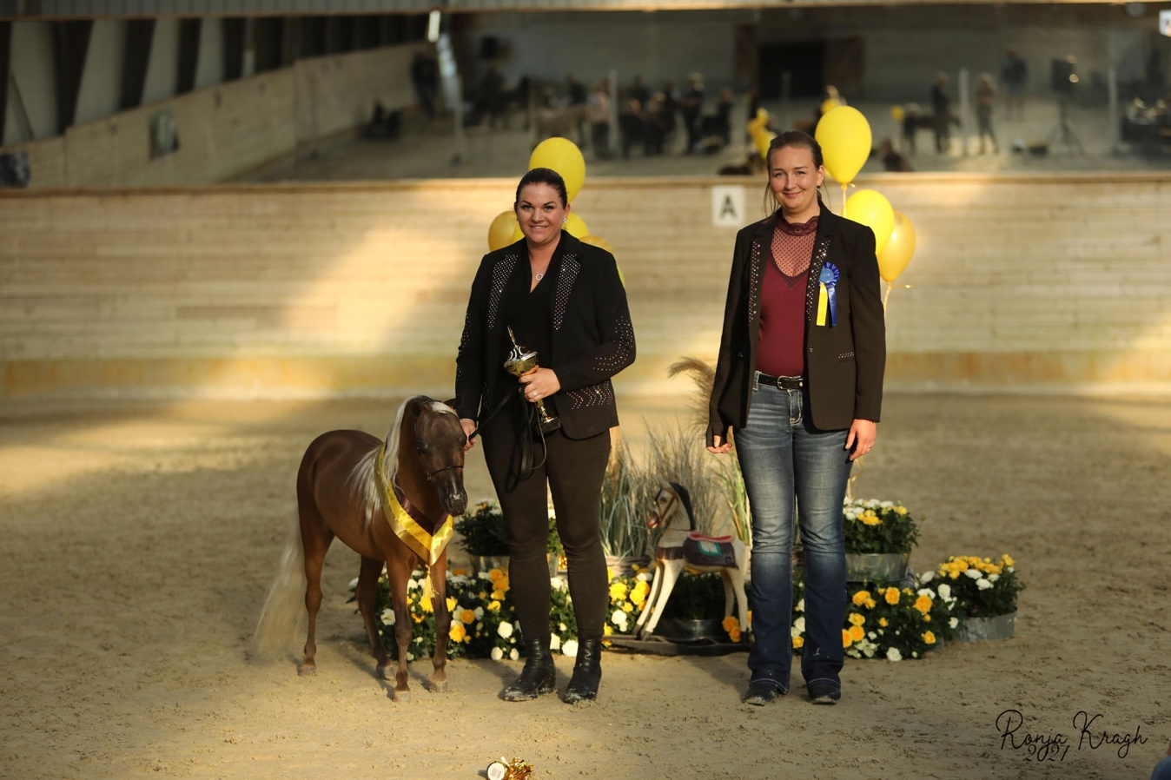

74) Best Driving Horse in Show

1st
Abrias Daring Eclipse

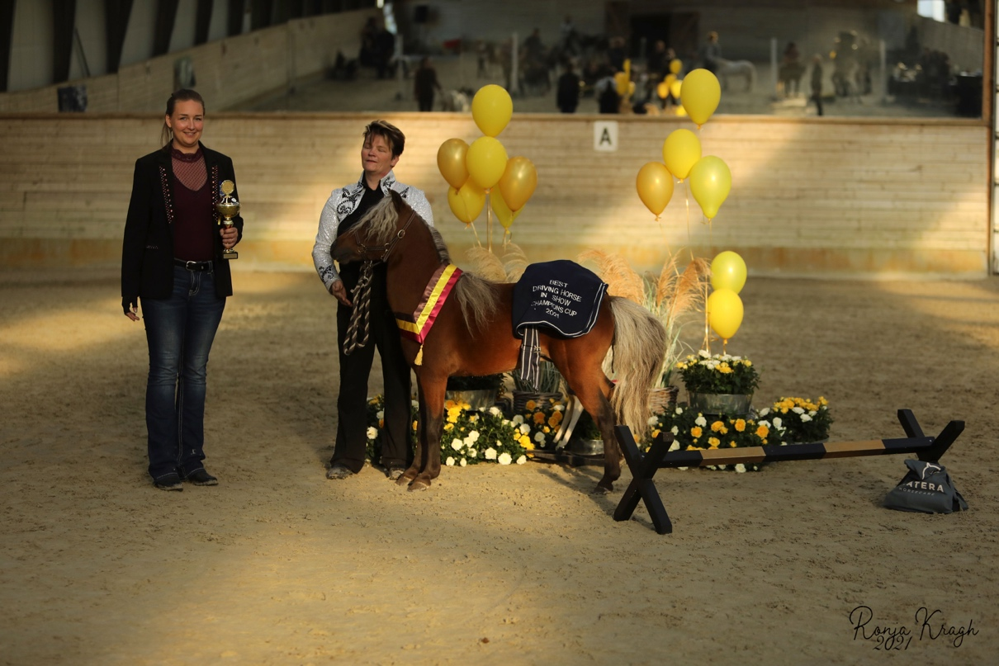

75) Best Performance Horse in Show

1st
The Golden Baron of Bali Hai

